Solution: Dynamic Drop-down Lists

Acme Insurance has decided that it wants to be able to link a contact note with a given interaction.

In this lab, you will both extend the existing data model and configure a worksheet PCF file to link a contact note for with a given interaction.

Requirements

This lab requires that you first complete labs from previous lessons including Creating Entities, Typelists, Editable List View Panels, Create new objects with Popups, and Entity Names.

This lab requires that you use TrainingApp 8.0, Guidewire Studio 8.0, and a supported web browser. To view, edit, and delete various contacts, log in to TrainingApp as Alice Applegate. The default URL for TrainingApp is http://localhost:8880/ab/ContactManager.do. The login/password for Alice Applegate is aapplegate/gw.

1. Modify an entity

In this exercise, you will extend the data model so that a contact note can be associated with zero or one interactions. In other words, you will make data model configuration changes so that a contact note can be associated with zero or one (not multiple) interactions.

Tasks

1. Open Guidewire Studio
2. From the bin folder, open a command window and start Guidewire Studio for TrainingApp.
3. Alternatively, use the Start TrainingApp Studio shortcut.
4. Extend the data model to create a field that would allow a ContactNote to save zero or one selected Interactions
5. Use the recommended naming practice for the new entity element.  
   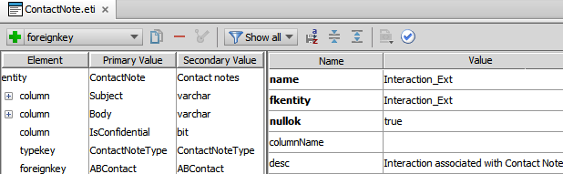
6. Build the data dictionary from the command window
7. From the bin folder, open a command window.
8. In the command window, enter the command to build the data dictionary.

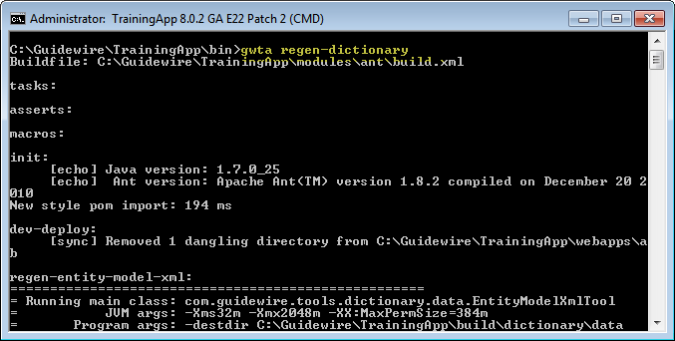

1. Open the data dictionary
2. In Windows Explorer, navigate to the data dictionary.
3. Open the data dictionary using Internet Explorer.
4. View the ContactNote entity
5. Verify each new field and associated datatype.

Deployment

1. Deploy your changes
2. From studio, restart the server using Debug 'Server'.
3. If open, review the Messages Make window for compilation errors.
4. Review the Debug console for errors.
5. Configuring PCFs

In this exercise, you will modify the worksheet for new contact notes. You will first add a new input column to the worksheet. Next, you will add an input widget that displays all the interactions related to the contact note's ABContact.

Tasks

1. Open Guidewire Studio for TrainingApp
2. From Studio, if your server is not already running, start the server using Debug 'Server'.
3. Review the Debug console for errors and verify that the application is running in the Debug console.
4. Modify the ContactNoteWorkSheet
5. Add an InputColumn widget to the right of the existing InputColumn widget in the Detail View Panel.

Add an editable input widget to the Input Column that will display zero or more interactions. Select the input widget type to best display and edit the field in a drop-down list.

Configure the input widget so that only the interactions related to the given ABContact are available for selection in the drop-down list.  
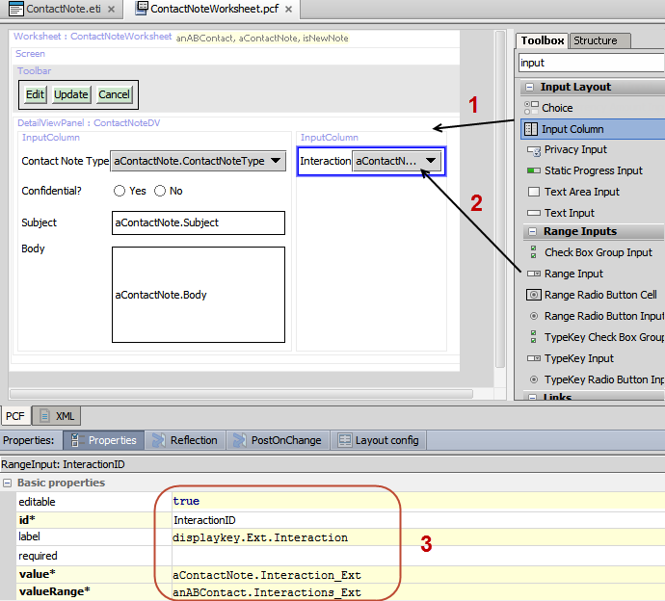

When specifying a value for the label, create a display key.

Verification

1. Verify the modified widget behavior
2. In TrainingApp, reload the changes to the PCF file(s) and display keys.
3. View the Interactions page for William Andy.
4. If William Andy does not have two or more Interactions, create at least two Interactions for William Andy.
5. In the Actions menus, select Workspace, then select New Note.

Specify values for Contact Note field values.

Verify that the Interaction drop-down list is visible and shows only the interactions for William Andy.

Select an Interaction in the Interaction drop-down list.

Click Update to save your changes.

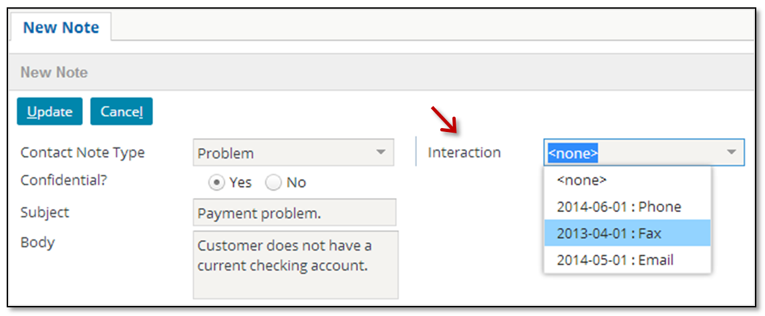

|  |  |
| --- | --- |
|  | Stop and ask your instructor to review your completed lab. |